https://www.cnblogs.com/zhaogaojian/p/9192618.html
^与$的含义
开头:^ 结尾:$ 例如以“123”开头以“abc”结尾可写成 ^123.*abc$

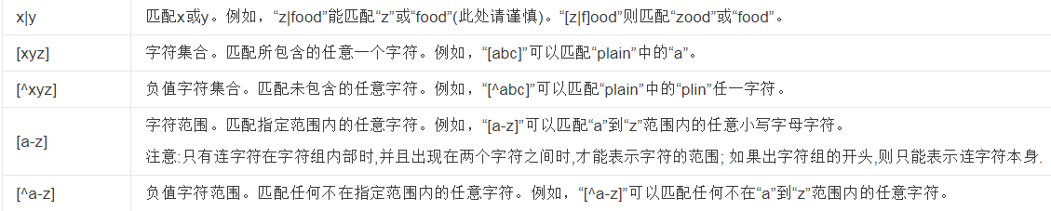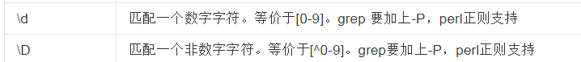

https://www.cnblogs.com/lwming/p/10943193.html
(?=a) (?<=a)

https://blog.csdn.net/u010084228/article/details/78332260?tdsourcetag=s_pcqq_aiomsg

